**Lab 03**

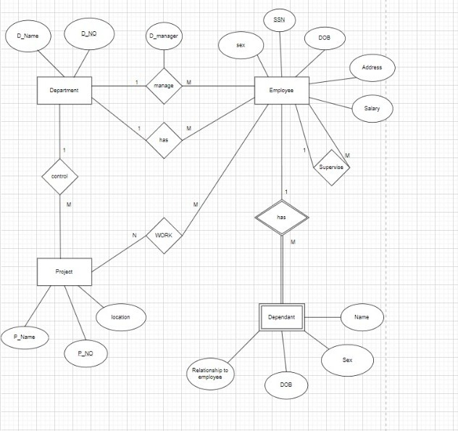

**Lab 04**

**Q1.**

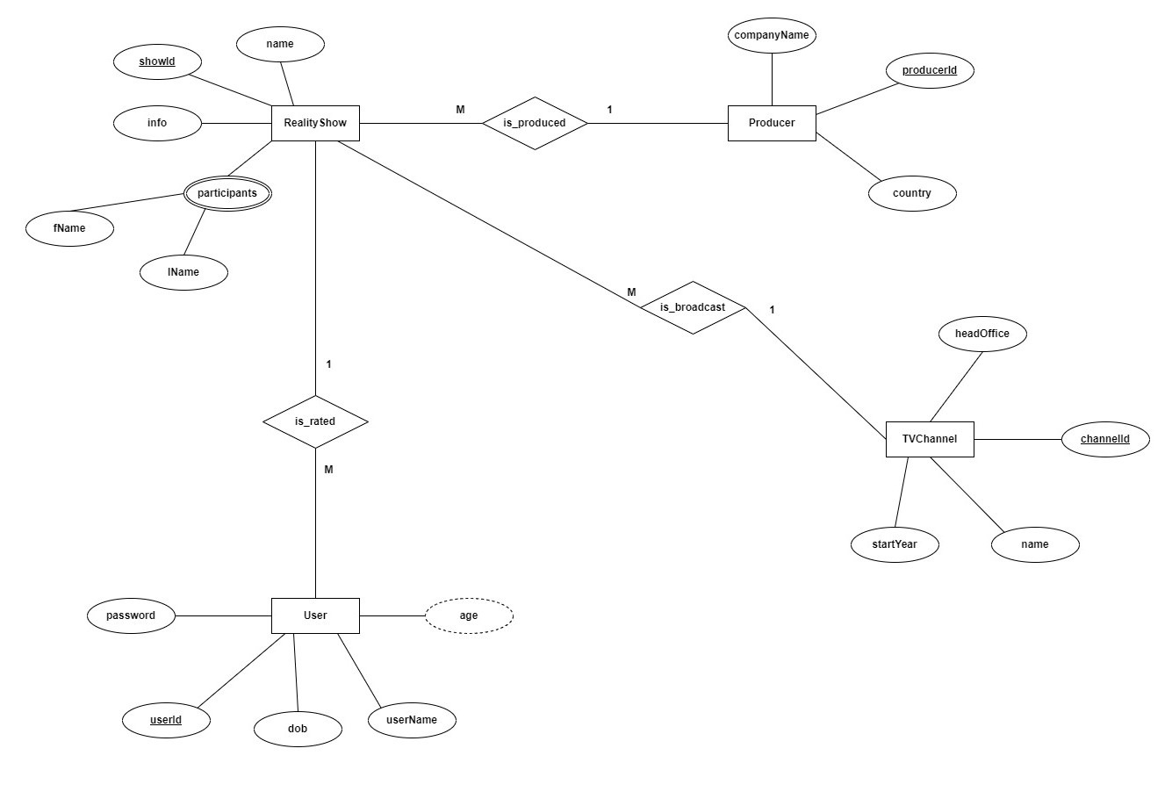

**Q2.**

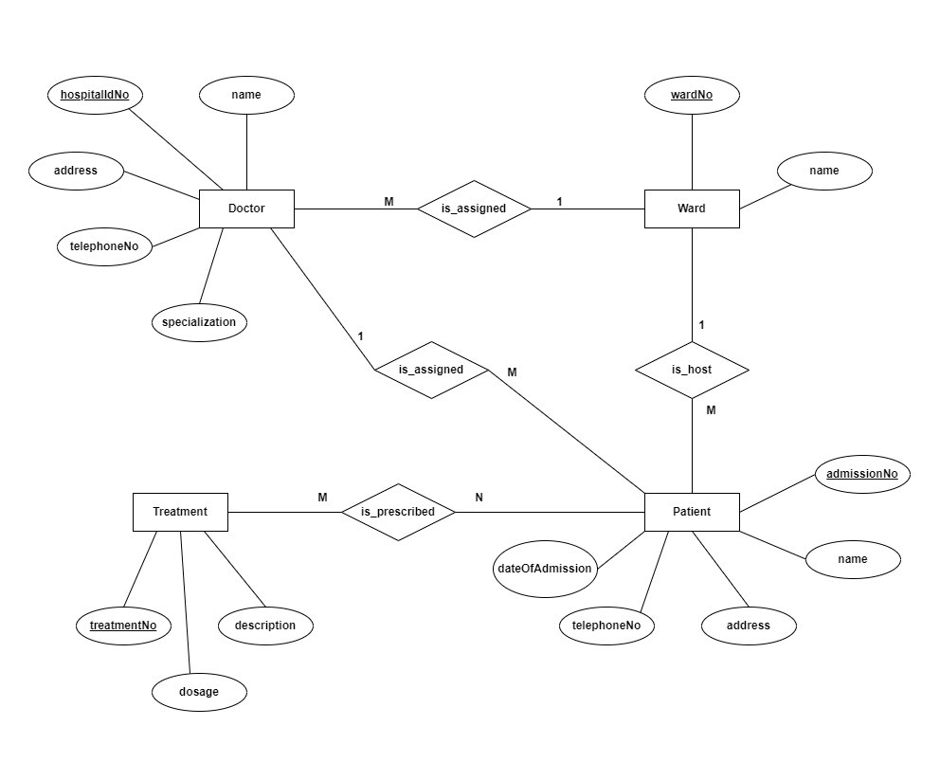

**Lab 05**

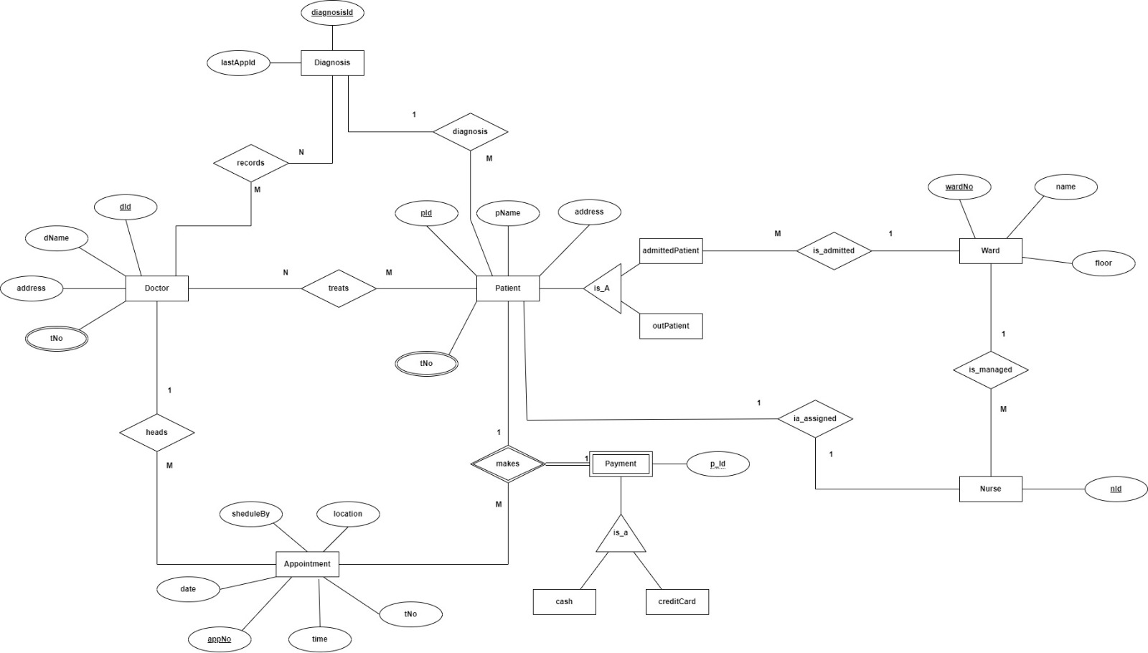

**Lab 06**



**Lab 09**



